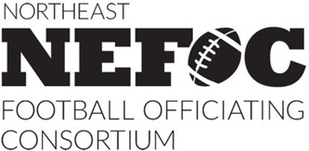

Football Official Physical Certification

Official's Name:

Address:

Based upon a physical examination, which I have personally conducted, I hereby certify the above-named individual is physically qualified to officiate college football.

Dated this day of , 20_ .

Physician's Signature and Stamp:

Please either email or mail a hard copy of this form to:

Bill Schuster
Coordinator of Football Officials NEFOC
4409 Hammocks DR
Geneseo, NY 14454
(585) 362-3920
ump129@gmail.com

